Elementary Assessment Project
Soccer

Merritt Smith
Coach Macko

Elementary Assessment Project Section 1, Parts A & B

Part A

Grade Level/s: 3rd grade Double class Mara McGinnis

Subject Area: Physical Education

Number of Students

Total: 37 M:15 F: 22

Class Characteristics

Race/Ethnicity: Caucasian:22 African American: 5 Hispanic: 9 Other: 1

Number of Students for Free or Reduced Lunch :11

Number of ESOL: 0 Number of EMH:0

Number of LD: 0 Number of EH:0

Number of SED: 0 Number of Gifted :15

Other (speech impaired/ hard of hearing): 4

Describe the Type of Classroom (i.e. homogeneous, heterogeneous,

The classroom type is heterogenous. The coaches also do the team teach model so every class is a doubles class, which can factor or influence certain activity’s we do due to lack of equipment/ or space. I see these students twice a week, so having a gap might affect their cognitive development in cue learning. I will utilize the outdoor laptop/ tv and microphone to enhance teaching.

B. Identifying the Topic You Will Teach and Its Relationship to the Curriculum

The topic I will be teaching is soccer, more specifically passing. Students have worked with other forms of passing the ball such as street hockey, volleyball, and frisbee. However, had not learned soccer with the understanding of passing and receiving cues, responsible behaviors, safety. These will all be beneficial in beginning the soccer/ passing unit. While in 3rd grade they understand how practicing something makes progress, and how different sports you pass in. the standard that will be focus on is PE.3.C.2.6 Analyze peer performance and provide feedback. The interdisciplinary content areas best used would be math, and possibly English!

Resource: HCPS Physical Education Content, CPALMS

Elementary Assessment Project Sections 2 & 3

Psychomotor:

PE.3.M.1.2 Strike a stationary object from a stationary position using body parts so that the object travels in the intended direction at the desired height.

Objective: SWBAT kick a soccer ball from a stationary position using all of the critical elements so it travels in the intended direction with 80% success.
SWBAT kick a soccer ball from a stationary position using all of the critical elements so it travels in the intended direction with 80% success.

Cognitive:

PE.3.C.2.6 Analyze peer performance and provide feedback

Objective: SWBAT identify each cue and how it helps with the performance in passing the soccer ball

Affective:
PE.3.R.6.1 List personally challenging physical- activity experiences

Objective: SWBAT list 2 challenging physical activity experiences associated with soccer/passing.

In order to assess each student they have corresponding numbers based off their vests I will be going off of.

Psychomotor:
This assessment will be done by a PRE/POST test. This will be done before the soccer unit and after.
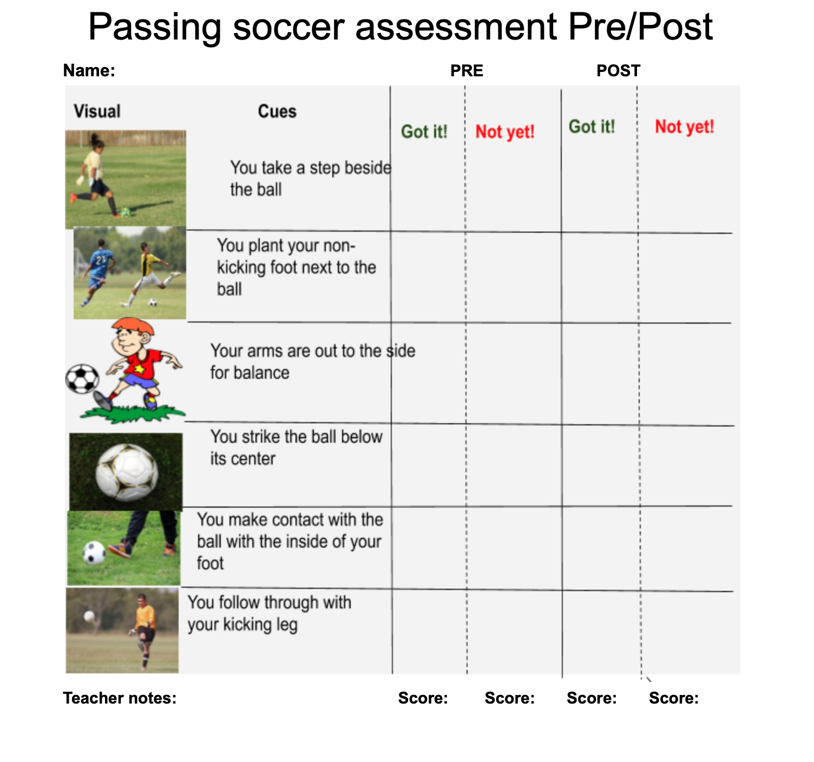

Cognitive:

They will be analyzing peers and providing feedback. They will be assigned partners, and stay with these partners. 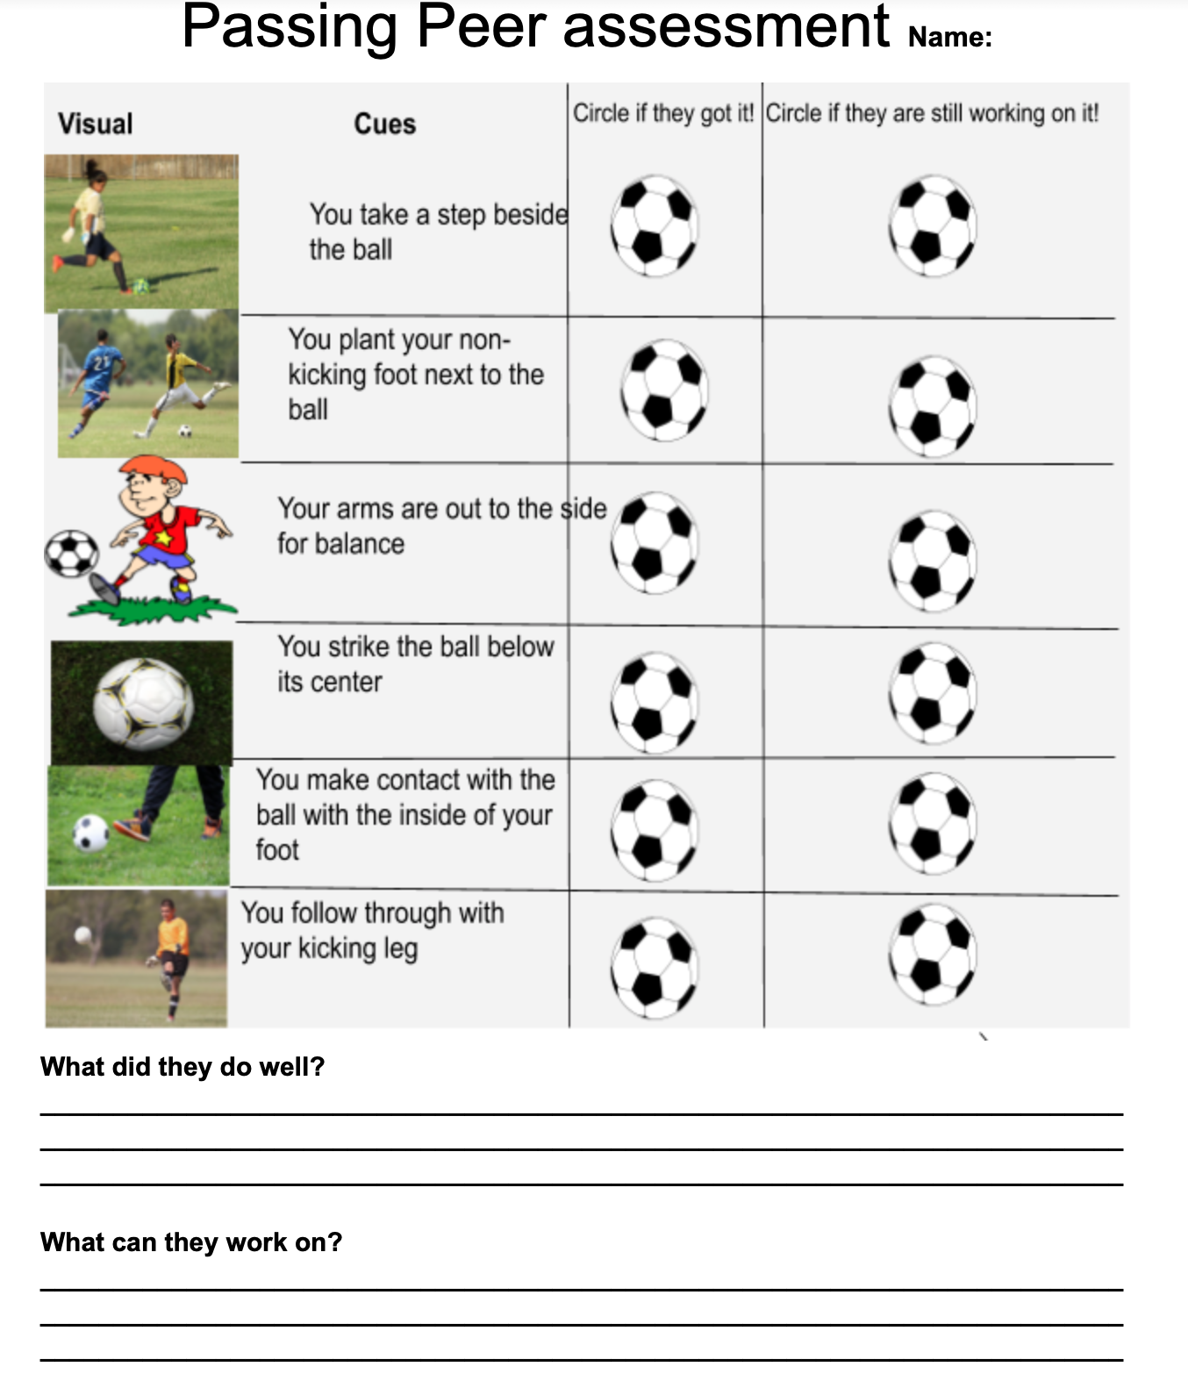

Affective:

Ex. you may have students answer a question, such as:
List 2 challenges you find associated with soccer kicking/passing.

In order to measure the feelings of the students, I will ask the students a question:
And have them respond on a sticky note and return to me.
QUESTION: List two challenges you find associated with soccer kicking/ passing

Unit Focus/Content Area: Passing (Feet)

Lesson #1 of 4
Date of Lesson: N/A
Grade Level: 3
Elementary GLSP: pre-control/control
Movement Concept(s): Space awareness → Location → Self-space
Effort → Force → Strong & Light
Relationships → With People → Solo/ Partners
Skill Theme: Passing:(cues: Plant non dominant foot next to ball, strike ball below its center, inside foot, follow through)

Interdisciplinary Focus: Science -> Forms of energy
Collaborating Teacher (CT): Macko
University Supervisor (US): Mr. Neiman
Prepared by: Merritt Smith

Central Learning Focus/Objectives (including interdisciplinary focus in at least one objective):
- Psychomotor
State- PE.3.M.1.2 Strike a stationary object from a stationary position using body parts so that the object travels in the intended direction at the desired height
National- Standard 1. The physically literate individual demonstrates competency in a variety of motor skills and movement patterns.
Objective(state the behavior, situation, & criterion)- SWBAT kick a soccer ball from a stationary position using all of the critical elements so it travels in intended direction with 80% success.

● Cognitive
State-PE.3.C.2.6 Analyze peer performance and provide feedback
Interdisciplinary Focus- SC.3.P.10. Recognize that energy has the ability to cause motion or create change.
National-Standard 2: The physically literate individual applies knowledge of concepts, principles, strategies and tactics related to movement and performance.
Objective(state the behavior, situation, & criterion)-By the end of class,SWBAT identify each cue and how it helps with the performance in passing the soccer ball

● Affective
State-PE.3.R.6.1 List personally challenging physical- activity experiences
National-Standard 4. The physically literate individual exhibits responsible personal and social behavior that respects self and others.
Objective(state the behavior, situation, & criterion)- SWBAT list 2 challenging physical activity experiences associated with soccer/passing.

- Teacher Objective: The teacher will limit the use of verbal viruses by replacing all gender specific language (i.e., guys, boys & girls) with gender neutral language (i.e., students, everyone, guys,class and OK,ALRIGHT)

Assessment Plans:
- Psychomotor
WHAT are you assessing?
- Students’ ability to demonstrate proper passing with their feet while performing the proper cues.
WHEN? (what task #'s?)
- During all tasks
HOW? (what tool are you using)
- Psychomotor Checklist
- Cognitive
WHAT are you assessing?
- Students ability to understand why proper cues are needed to pass correctly.
WHEN? (what task #'s?)
- end of class/ intro/ pre/post asses
HOW? (what tool are you using)
-group talking and discussion/checklist
- Affective
WHAT are you assessing?
- Students’ ability to list challenging activities
WHEN? (what task #'s?)
- closure
HOW? (what tool are you using)
- End of class discussion, WITI (why is this important?)

- Teacher Objective
WHAT are you assessing?
-The number of times the teacher uses "students/everyone/class" instead of "guys" or "boys & girls, also ok or alright
WHEN? (what task #'s?)
- throughout the full duration of class
HOW? (what tool are you using)
- Peer-Assisted, teacher observations

Materials/Equipment Needed (specific types & amounts):
- Music player, 14x Cones, 14x Soccer/Gator balls

Pre-Class Setup:

Resources:
http://www.cpalms.org
Graham, G., Holt/Hale, S.A., & Parker, M. (2012). Children Moving (9th. ed.). New York: McGraw-Hill.
https://www.shapeamerica.org/standards/pe/

Physical Safety Considerations:
-appropriate footwear must be worn (no open toed shoes, flip flops, or sandals)
-activity area must be free of all obstacles, and surface must provide safe footing and traction
-boundary lines must be communicated to students

Psychological/Emotional Safety Considerations (i.e., skill level, grouping, student relationships):
-avoid differential treatment
-discourage taunting/bullying and encourage good sportsmanship

Individual Learning Needs:

How does this lesson connect to the interests and cultural backgrounds of your students?
- passing/dribbling with feet is a very important skill in the sport of soccer. A lot of families watch soccer events such as the world cup and other various leagues. Soccer plays a large role in European and Hispanic cultures.

How will you make this lesson connect to/reflect the local community?
Dribbling/passing with feet is a very important skill when it comes to being able to play soccer. There are multiple club/rec soccer teams around Hillsborough county that students are able to join. Also Tampa Bay has a team called the rowdies that students may be aware of.

How will you differentiate instruction for students who need additional language support?
- use of demonstration and visuals

How will you adapt/modify instruction and activities for students with disabilities?
- Autism- visuals, schedule board, token economy, peer buddy, assign less difficult locomotor movements
Deaf- visuals, semi-circle, peer buddy
VI- proximity from peers, peer buddy, physical guidance, sound sources
ID- decrease catching distances, assign less difficult locomotor movements, peer buddy
OHI- peer buddy
Orthopedic Impairments- peer buddy

How will you differentiate instruction and activities for students who need additional challenge (enrichment) during this lesson?
-teach the next cue(s)
-assign higher skilled students further distances to pass too
- give students of lower skilled a shorter distance to pass too

Specific Accommodations (if applicable):
-

INSTRUCTIONAL PLAN

Instant Activity: toe fencing
Time: 4-5 minutes
Materials/Equipment: foam noodles

Description (scripted):

Good Morning Class! Today we are going to do a fun activity before we start our lesson! Toe fencing requires quick movements such as hopping, darting, dashing, and leaping. You are not allowed to run away and must stay in your general space. In toe fencing each of you will have a foam noodle and the object is to touch your partner’s feet. Feet only, not the head, leg, arm or any other part of the body. When toe fencing you will not raise your foam noodle above your waist. Fencing requires you to poke the opponent in order to be successful. When you have successfully poked your partners feet they must do a type of exercise such as pushup, jumping jack, etc. The first time you are poked you do five, the second time ten, third time fifteen and so forth. (Show demonstration). (Assign partners based off colored cones ie. red row with blue row). WISG I want you and your partner to grab a foam noodle and go to a poly spot. Do not begin until directed to do so. Go!

Set Induction:Good morning class! Is everyone in assigned seats? Great . Can anyone tell me a sport we might need to pass in? Yes, those are correct.

Introduction (Informing): So today can someone look at the board and tell me what we are learning? Great. What are we going to be looking for? Yes! But today we are going to be focusing on the cue of the inside foot! Can you point to the side of your foot?
very good. We are going to use the inside foot to pass with the ball today when we do stations! today we are going to do soccer stations to assess where you are at currently in soccer, don’t worry if you feel like the soccer ball isn’t going to your target this is only the first time this year working on this skill! you should be familiar with soccer from last year though. *begin calling out groups of four to each station*
But before we begin we need to go over our management and safety. and let's go over the stations for today!
BOARD:
WALT- Passing
WILF- Plant non dominant foot next to ball, strike ball below its center, inside foot, follow through
WITI- This is important to perform proper technique of dribbling to maintain control of our object at our feet.

Reiterate:
Safety
While dribbling/ or passing we are going to be staying in our own personal space by our cones. If your ball rolls away please do not continue to try and dribble/ or pass it. Pick it up with your hands and return to your cone.
Management Cues
When I say freeze I want you to TRAP your soccer ball underneath your dominant foot. If you are unable to hold a trap you must keep it between your feet until further directions.

I will be walking around station 1 for a gathering of pre assessment checklist for psychomotor using my cue sheet. asking for the students name and filling them out. station two students will be doing a peer assessment on each other for cognitive. and affective will be tested in closure!

Task #1: Stationary passing between gates with partners
Time: 5 minutes
Cue: Inside foot
Materials/Equipment: Cones, Soccer Ball
Description (scripted): WISG I want you to start with the inside of your dominant foot and pass the ball to your partner. When it gets to your partner, they are going to take their opposite foot and place it on top of the soccer ball to stop it. Show Demonstration. Please continue doing this until you hear me say FREEZE. Go!
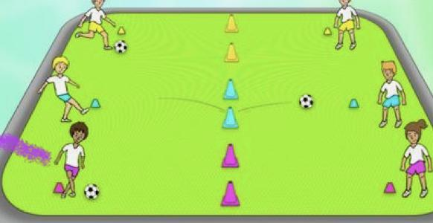
*have this picture on cone for visual reminder*
Extending/Refining/Application:
E- ok, now make the gates narrower
E- Take a step back after every 5 successful traps in a row
R- Remember to Tude the inside of your foot.
A- Let's see if we can get 10 successful passes and traps in a row

Transition to the next task (scripted): Freeze! Eyes on me. Thank you everyone for trapping ! What cue are we focusing on today? (Show Demo of that cue) now, switch stations clockwise.

Task #2: Passing to moving partner (cognitive station)
Time: 5 minutes
Cue: inside foot
Materials/Equipment: Soccer, Cones, stop watch
Description (scripted): WISG, partner one will start will the soccer ball and pass to the empty cone, where partner two will move to recieve it from the third cone, the partners will rotate clockwise in a triangle, always advancing towards the empty cone to receive the soccer ball. as you are passing to your partner you are analyzing their skills to assess them using a sheet. the last minute in the station uses this time to analyze and peer assess. Show Demonstration. Please continue doing this until you hear me say FREEZE. Go!

Extending/Refining/Application:
E- Spread the cones out further, to increase the difficulty
R- Remember we are using the inside of our feet
A- See if you can continuously keep passing under control for two minutes straight!

Transition to the next task (scripted): Freeze! Eyes on me. Thank you everyone for trapping! now, we are going to switch stations clockwise!

Task #3: Dribbling through cones
Time: 5 minutes
Cue: Inside foot
Materials/Equipment: Cones, Soccer ball
Description (scripted): Now we are gonna try dribbling through cones! dribbling is great to help with ball control, make sure we keep the soccer ball close to us and use the inside of our foot! *demonstrate* each person will begin going one at a time and come back and return to end of line before the next person starts! GO!

Extending/Refining/Application:
E- See if you can dribble faster.
R- Remember we are using the inside of our feet
A- Try to not lose control within 1 minute!

Transition to the next task (scripted): Freeze! Eyes on me. Thank you everyone for trapping! now, we are going to switch stations clockwise!

Task #4: kicking to target
Time: 5 minutes
Cue: inside foot
Materials/Equipment: Soccer/ Cone
Description (scripted): WISG I want you to find your poly spot and place your soccer ball there, in front of you is a small goal where your partner will be in front of being a goalie, your job is to kick to target once you made an attempt you return your soccer ball back to the poly spot, and your partner becomes the kicker, and you become the goalie. repeat until whistle. *demonstrate* GO!
Extending/Refining/Application:
E- Try taking a step back from the poly spot every time you make a goal
R- Remember we are using the inside of our feet
A- See if you can make 10 goals in 3 minutes

Transition to closure: Freeze! Eyes on me. Thank you everyone for listening ! good job everyone I see a lot of you following directions and performing the cue. please return to our seats for closure

Closure (scripted): Great Job today class I noticed a lot of you were using the cues we went over before class and really started to get the inside foot cue down!. So today can someone tell me what we started learning? Great. What are we looking for while passing Yes! But today what did we focus on? the cue of inside foot.

Before you leave, you will grab a sticky note and write your name and based on the four stations list them from 1 least challenging to 4 most challenging.

Now when you are done with your sticky note assessment, Please go stand on the yellow line. Thank you everyone for being respectful to one another and cooperating. Red row, blue row etc.

WALT- Passing
WILF- Plant non dominant foot next to ball, strike ball below its center, inside foot, follow through
WITI- This is important to perform proper technique of dribbling to maintain control of our object at our feet.

Unit Focus/Content Area: Dribbling (Feet)

Lesson #2 of 4
Date of Lesson: N/A
Grade Level: 3
Elementary GLSP: pre-control/control
Movement Concept(s): Space awareness → Location → Self-space
Effort → Force → Strong & Light
Relationships → With People → Solo/ Partners
Skill Theme: Passing:(cues: Plant non dominate foot next to ball, strike ball below its center, inside foot, follow through)

Interdisciplinary Focus: Science -> Forms of energy
Collaborating Teacher (CT): Macko
University Supervisor (US): Mr. Neiman
Prepared by: Merritt Smith

Central Learning Focus/Objectives (including interdisciplinary focus in at least one objective):
- Psychomotor
State- PE.3.M.1.2 Strike a stationary object from a stationary position using body parts so that the object travels in the intended direction at the desired height
National- Standard 1. The physically literate individual demonstrates competency in a variety of motor skills and movement patterns.
Objective(state the behavior, situation, & criterion)- SWBAT kick a soccer ball from a stationary position using all of the critical elements so it travels in intended direction with 80% success.

● Cognitive
State-PE.3.C.2.6 Analyze peer performance and provide feedback
Interdisciplinary Focus- SC.3.P.10. Recognize that energy has the ability to cause motion or create change.
National-Standard 2: The physically literate individual applies knowledge of concepts, principles, strategies and tactics related to movement and performance.
Objective(state the behavior, situation, & criterion)-By the end of class,SWBAT identify each cue and how it helps with the performance in passing the soccer ball

● Affective
State-PE.3.R.6.1 List personally challenging physical- activity experiences
National-Standard 4. The physically literate individual exhibits responsible personal and social behavior that respects self and others.
Objective(state the behavior, situation, & criterion)- SWBAT list 2 challenging physical activity experiences associated with soccer/passing.

- Teacher Objective: The teacher will limit the use of verbal viruses by replacing all gender specific language (i.e., guys, boys & girls) with gender neutral language (i.e., students, everyone, guys,class and OK,ALRIGHT)

Assessment Plans:
- Psychomotor
WHAT are you assessing?
- Students’ ability to demonstrate proper passing with their feet while performing the proper cues.
WHEN? (what task #'s?)
- During all tasks
HOW? (what tool are you using)
- Psychomotor Checklist
- Cognitive
WHAT are you assessing?
- Students ability to understand why proper cues are needed to pass correctly.
WHEN? (what task #'s?)
- end of class/ intro/ pre/post asses
HOW? (what tool are you using)
-group talking and discussion/checklist
- Affective
WHAT are you assessing?
- Students’ ability to list challenging activities
WHEN? (what task #'s?)
- closure
HOW? (what tool are you using)
- End of class discussion, WITI (why is this important?)

- Teacher Objective
WHAT are you assessing?
-The number of times the teacher uses "students/everyone/class" instead of "guys" or "boys & girls, also ok or alright
WHEN? (what task #'s?)
- throughout the full duration of class
HOW? (what tool are you using)
- Peer-Assisted, teacher observations

Materials/Equipment Needed (specific types & amounts):
- Music player, 14x Cones, 14x Soccer/Gator balls

Pre-Class Setup:

Resources:
http://www.cpalms.org
Graham, G., Holt/Hale, S.A., & Parker, M. (2012). Children Moving (9th. ed.). New York: McGraw-Hill.
https://www.shapeamerica.org/standards/pe/

Physical Safety Considerations:
-appropriate footwear must be worn (no open toed shoes, flip flops, or sandals)
-activity area must be free of all obstacles, and surface must provide safe footing and traction
-boundary lines must be communicated to students

Psychological/Emotional Safety Considerations (i.e., skill level, grouping, student relationships):
-avoid differential treatment
-discourage taunting/bullying and encourage good sportsmanship

Individual Learning Needs:

How does this lesson connect to the interests and cultural backgrounds of your students?
- passing/dribbling with feet is a very important skill in the sport of soccer. A lot of families watch soccer events such as the world cup and other various leagues. Soccer plays a large role in European and Hispanic cultures.

How will you make this lesson connect to/reflect the local community?
Dribbling/passing with feet is a very important skill when it comes to being able to play soccer. There are multiple club/rec soccer teams around Hillsborough county that students are able to join. Also Tampa Bay has a team called the rowdies that students may be aware of.

How will you differentiate instruction for students who need additional language support?
- use of demonstration and visuals

How will you adapt/modify instruction and activities for students with disabilities?
- Autism- visuals, schedule board, token economy, peer buddy, assign less difficult locomotor movements
Deaf- visuals, semi-circle, peer buddy
VI- proximity from peers, peer buddy, physical guidance, sound sources
ID- decrease catching distances, assign less difficult locomotor movements, peer buddy
OHI- peer buddy
Orthopedic Impairments- peer buddy

How will you differentiate instruction and activities for students who need additional challenge (enrichment) during this lesson?
-teach the next cue(s)
-assign higher skilled students further distances to pass too
- give students of lower skilled a shorter distance to pass too

Specific Accommodations (if applicable):
-

INSTRUCTIONAL PLAN

Instant Activity: toe fencing
Time: 4-5 minutes
Materials/Equipment: foam noodles

Description (scripted):

Good Morning Class! Today we are going to do a fun activity before we start our lesson! Toe fencing requires quick movements such as hopping, darting, dashing, and leaping. You are not allowed to run away and must stay in your general space. In toe fencing each of you will have a foam noodle and the object is to touch your partner’s feet. Feet only, not the head, leg, arm or any other part of the body. When toe fencing you will not raise your foam noodle above your waist. Fencing requires you to poke the opponent in order to be successful. When you have successfully poked your partners feet they must do a type of exercise such as pushup, jumping jack, etc. The first time you are poked you do five, the second time ten, third time fifteen and so forth. (Show demonstration). (Assign partners based off colored cones ie. red row with blue row). WISG I want you and your partner to grab a foam noodle and go to a poly spot. Do not begin until directed to do so. Go!

Set Induction:Good morning class! Is everyone in assigned seats? Great .Can anyone tell me a sport we might need to pass in? Yes, those are correct.

Introduction (Informing):
WALT- Passing (Stationary)
WILF- Plant non dominant foot next to ball, strike ball below its center, inside foot, follow through
WITI- This is important to perform proper technique of passing to maintain control/accuracy of the soccer ball

Reiterate:
Safety
While dribbling/ or passing we are going to be staying in our own personal space by our cones. If your ball rolls away please do not continue to try and dribble/ or pass it. Pick it up with your hands and return to your cone.
Management Cues
When I say freeze I want you to TRAP your soccer ball underneath your dominant foot. If you are unable to hold a trap you must keep it between your feet until further directions.

Task #1: Stationary passing between gates with partners
Time: 5 minutes
Cue: Inside foot
Materials/Equipment: Cones, Soccer Ball
Description (scripted): WISG I want you to start with the inside of your dominant foot and pass the ball to your partner. When it gets to your partner, they are going to take their opposite foot and place it on top of the soccer ball to stop it. Show Demonstration. Please continue doing this until you hear me say FREEZE. Go!
*have this picture on cone for visual reminder*
Extending/Refining/Application:
E- ok, now make the gates narrower
E- Take a step back after every 5 successful traps in a row
R- Remember to Tude the inside of your foot.
A- Let's see if we can get 10 successful passes and traps in a row

Transition to the next task (scripted): Freeze! Eyes on me. Thank you everyone for trapping ! What cue are we focusing on today?

Task #2 Stationary passing with partners
Time: 3 minutes
Cue: inside foot
Materials/Equipment: Soccer, poly spots
Description (scripted): WISG, you are going to pass to your partner who is at the other poly spot with your opposite foot!
Extending/Refining/Application:
E- Now, you can try passing fast!
E- Now, try passing slow!
E- Now, passing in air!
R- Remember we are using the inside of our feet
A- See if you can continuously keep passing under control for 50 in a row!

Transition to closure: Freeze! Eyes on me. Thank you everyone for listening ! good job everyone I see a lot of you following directions and performing the cue. please return to our seats for closure

Closure (scripted): Great Job class focusing on passing! I noticed a lot of you were using the cues we went over before class and really started to get your non dominant foot down!.
Why is it important that we plant our non dominant foot? And what was your favorite extension today?
- Now when I call your colored cone Please go stand on the yellow line. Thank you everyone for being respectful to one another and cooperating. Red row, blue row etc.

Cue focus:
Plant non dominant foot next to ball

WALT- Passing (Stationary)
WILF- Plant non dominant foot next to ball, strike ball below its center, inside foot, follow through
WITI- This is important to perform proper technique of passing to maintain control/accuracy of the soccer ball

Unit Focus/Content Area: Dribbling (Feet)

Lesson #3 of 4
Date of Lesson: N/A
Grade Level: 3
Elementary GLSP: pre-control/control
Movement Concept(s): Space awareness → Location → Self-space
Effort → Force → Strong & Light
Relationships → With People → Solo/ Partners
Skill Theme: Passing:(cues: Plant non dominate foot next to ball, strike ball below its center, inside foot, follow through)

Interdisciplinary Focus: Science -> Forms of energy
Collaborating Teacher (CT): Macko
University Supervisor (US): Mr. Neiman
Prepared by: Merritt Smith

Central Learning Focus/Objectives (including interdisciplinary focus in at least one objective):
- Psychomotor
State- PE.3.M.1.2 Strike a stationary object from a stationary position using body parts so that the object travels in the intended direction at the desired height
National- Standard 1. The physically literate individual demonstrates competency in a variety of motor skills and movement patterns.
Objective(state the behavior, situation, & criterion)- SWBAT kick a soccer ball from a stationary position using all of the critical elements so it travels in intended direction with 80% success.

● Cognitive
State-PE.3.C.2.6 Analyze peer performance and provide feedback
Interdisciplinary Focus- SC.3.P.10. Recognize that energy has the ability to cause motion or create change.
National-Standard 2: The physically literate individual applies knowledge of concepts, principles, strategies and tactics related to movement and performance.
Objective(state the behavior, situation, & criterion)-By the end of class,SWBAT identify each cue and how it helps with the performance in passing the soccer ball

● Affective
State-PE.3.R.6.1 List personally challenging physical- activity experiences
National-Standard 4. The physically literate individual exhibits responsible personal and social behavior that respects self and others.
Objective(state the behavior, situation, & criterion)- SWBAT list 2 challenging physical activity experiences associated with soccer/passing.

- Teacher Objective: The teacher will limit the use of verbal viruses by replacing all gender specific language (i.e., guys, boys & girls) with gender neutral language (i.e., students, everyone, guys,class and OK, ALRIGHT)

Assessment Plans:
- Psychomotor
WHAT are you assessing?
- Students’ ability to demonstrate proper passing with their feet while performing the proper cues.
WHEN? (what task #'s?)
- During all tasks
HOW? (what tool are you using)
- Psychomotor Checklist
- Cognitive
WHAT are you assessing?
- Students' ability to understand why proper cues are needed to pass correctly.
WHEN? (what task #'s?)
- end of class/ intro/ pre/post asses
HOW? (what tool are you using)
-group talking and discussion/checklist
- Affective
WHAT are you assessing?
- Students’ ability to list challenging activities
WHEN? (what task #'s?)
- closure
HOW? (what tool are you using)
- End of class discussion, WITI (why is this important?)

- Teacher Objective
WHAT are you assessing?
-The number of times the teacher uses "students/everyone/class" instead of "guys" or "boys & girls, also ok or alright
WHEN? (what task #'s?)
- throughout the full duration of class
HOW? (what tool are you using)
- Peer-Assisted, teacher observations

Materials/Equipment Needed (specific types & amounts):
- Music player, 14x Cones, 14x Soccer/Gator balls

Pre-Class Setup:

Resources:
http://www.cpalms.org
Graham, G., Holt/Hale, S.A., & Parker, M. (2012). Children Moving (9th. ed.). New York: McGraw-Hill.
https://www.shapeamerica.org/standards/pe/

Physical Safety Considerations:
-appropriate footwear must be worn (no open toed shoes, flip flops, or sandals)
-activity area must be free of all obstacles, and surface must provide safe footing and traction
-boundary lines must be communicated to students

Psychological/Emotional Safety Considerations (i.e., skill level, grouping, student relationships):
-avoid differential treatment
-discourage taunting/bullying and encourage good sportsmanship

Individual Learning Needs:

How does this lesson connect to the interests and cultural backgrounds of your students?
- passing/dribbling with feet is a very important skill in the sport of soccer. A lot of families watch soccer events such as the world cup and other various leagues. Soccer plays a large role in European and Hispanic cultures.

How will you make this lesson connect to/reflect the local community?
Dribbling/passing with feet is a very important skill when it comes to being able to play soccer. There are multiple club/rec soccer teams around Hillsborough county that students are able to join. Also Tampa Bay has a team called the rowdies that students may be aware of.

How will you differentiate instruction for students who need additional language support?
- use of demonstration and visuals

How will you adapt/modify instruction and activities for students with disabilities?
- Autism- visuals, schedule board, token economy, peer buddy, assign less difficult locomotor movements
Deaf- visuals, semi-circle, peer buddy
VI- proximity from peers, peer buddy, physical guidance, sound sources
ID- decrease catching distances, assign less difficult locomotor movements, peer buddy
OHI- peer buddy
Orthopedic Impairments- peer buddy

How will you differentiate instruction and activities for students who need additional challenge (enrichment) during this lesson?
-teach the next cue(s)
-assign higher skilled students further distances to pass too
- give students of lower skilled a shorter distance to pass too

Specific Accommodations (if applicable):
-

INSTRUCTIONAL PLAN

Instant Activity: toe fencing
Time: 4-5 minutes
Materials/Equipment: foam noodles

Description (scripted):

Good Morning Class! Today we are going to do a fun activity before we start our lesson! Toe fencing requires quick movements such as hopping, darting, dashing, and leaping. You are not allowed to run away and must stay in your general space. In toe fencing each of you will have a foam noodle and the object is to touch your partner’s feet. Feet only, not the head, leg, arm or any other part of the body. When toe fencing you will not raise your foam noodle above your waist. Fencing requires you to poke the opponent in order to be successful. When you have successfully poked your partners feet they must do a type of exercise such as pushup, jumping jack, etc. The first time you are poked you do five, the second time ten, third time fifteen and so forth. (Show demonstration). (Assign partners based off colored cones ie. red row with blue row). WISG I want you and your partner to grab a foam noodle and go to a poly spot. Do not begin until directed to do so. Go!

Set Induction:Good morning class! Is everyone in assigned seats? Great .Can anyone tell me a sport we might need to pass in? Yes, those are correct.

Introduction (Informing):
WALT- Passing (moving)
WILF- Plant non dominant foot next to ball, strike ball below its center, inside foot, follow through
WITI- This is important to perform proper technique of passing to maintain control/accuracy of the soccer ball

Reiterate:
Safety
While dribbling/ or passing we are going to be staying in our own personal space by our cones. If your ball rolls away please do not continue to try and dribble/ or pass it. Pick it up with your hands and return to your cone.
Management Cues
When I say freeze I want you to TRAP your soccer ball underneath your dominant foot. If you are unable to hold a trap you must keep it between your feet until further directions.

Task #1: Stationary passing with partners
Time: 5 minutes
Cue: Inside foot
Materials/Equipment: Cones, Soccer Ball
Description (scripted): WISG I want you to start with the inside of your dominant foot and pass the ball to your partner. When it gets to your partner, they are going to take their opposite foot and place it on top of the soccer ball to stop it. Show Demonstration. Please continue doing this until you hear me say FREEZE. Go!

Extending/Refining/Application:
E- ok, now make the gates narrower
E- Take a step back after every 5 successful traps in a row
R- Remember to follow through!
A- Let's see if we can get 10 successful passes and traps in a row

Transition to the next task (scripted): Freeze! Eyes on me. Thank you everyone for trapping ! What cue are we focusing on today?

Task #2 Passing and moving to partner (Side to side)
Time: 7 minutes
Cue: inside foot
Materials/Equipment: Soccer, poly spots
Description (scripted): WISG, you are going to pass to your partner who is at the other poly spot.

Extending/Refining/Application:
E- now, pass to the right of your partner
E- Now pass to the left of your partner
R- Remember we are following through
A- See if you can continuously keep passing under control for 10 in a row!

Transition to the next task (scripted): Freeze! Eyes on me. Thank you everyone for trapping ! lets move on to the next task

Task #3 Passing and moving to partner (forwards/backwards)
Time: 7 minutes
Cue: inside foot
Materials/Equipment: Soccer, poly spots
Description (scripted): WISG, you are going to pass to your partner who is at the other poly spot first you will pass in front of your partner

Extending/Refining/Application:
E- now, pass behind your partner
E- Now pass front, behind, left, or right!
R- Remember we are following through
A- See if you can continuously keep passing under control for 10 in a row!

Transition to closure: Freeze! Eyes on me. Thank you everyone for listening ! good job everyone I see a lot of you following directions and performing the cue. please return to our seats for closure

Closure (scripted): Great Job class focusing on passing! I noticed a lot of you were using the cues we went over before class and really started to get following through down!
Why is it important that we follow through? Can i have someone come up and show me an example of following through and a non example of someone following through??? And what was your favorite extension today?
- Now when I call your colored cone Please go stand on the yellow line. Thank you everyone for being respectful to one another and cooperating. Red row, blue row etc.

Cue focus:
Follow through

WALT- Passing (moving)
WILF- Plant non dominant foot next to ball, strike ball below its center, inside foot, follow through
WITI- This is important to perform proper technique of passing to maintain control/accuracy of the soccer ball

Unit Focus/Content Area: Passing (Feet)

Lesson #4 of 4
Date of Lesson: N/A
Grade Level: 3
Elementary GLSP: pre-control/control
Movement Concept(s): Space awareness → Location → Self-space
Effort → Force → Strong & Light
Relationships → With People → Solo/ Partners
Skill Theme: Passing:(cues: Plant non dominate foot next to ball, strike ball below its center, inside foot, follow through)

Interdisciplinary Focus: Science -> Forms of energy
Collaborating Teacher (CT): Macko
University Supervisor (US): Mr. Neiman
Prepared by: Merritt Smith

Central Learning Focus/Objectives (including interdisciplinary focus in at least one objective):
- Psychomotor
State- PE.3.M.1.2 Strike a stationary object from a stationary position using body parts so that the object travels in the intended direction at the desired height
National- Standard 1. The physically literate individual demonstrates competency in a variety of motor skills and movement patterns.
Objective(state the behavior, situation, & criterion)- SWBAT kick a soccer ball from a stationary position using all of the critical elements so it travels in the intended direction with 80% success.

● Cognitive
State-PE.3.C.2.6 Analyze peer performance and provide feedback
Interdisciplinary Focus- SC.3.P.10. Recognize that energy has the ability to cause motion or create change.
National-Standard 2: The physically literate individual applies knowledge of concepts, principles, strategies and tactics related to movement and performance.
Objective(state the behavior, situation, & criterion)-By the end of class,SWBAT identify each cue and how it helps with the performance in passing the soccer ball

● Affective
State-PE.3.R.6.1 List personally challenging physical- activity experiences
National-Standard 4. The physically literate individual exhibits responsible personal and social behavior that respects self and others.
Objective(state the behavior, situation, & criterion)- SWBAT list 2 challenging physical activity experiences associated with soccer/passing.

- Teacher Objective: The teacher will limit the use of verbal viruses by replacing all gender specific language (i.e., guys, boys & girls) with gender neutral language (i.e., students, everyone, guys,class and OK,ALRIGHT)

Assessment Plans:
- Psychomotor
WHAT are you assessing?
- Students’ ability to demonstrate proper passing with their feet while performing the proper cues.
WHEN? (what task #'s?)
- During all tasks
HOW? (what tool are you using)
- Psychomotor Checklist
- Cognitive
WHAT are you assessing?
- Students ability to understand why proper cues are needed to pass correctly.
WHEN? (what task #'s?)
- end of class/ intro/ pre/post asses
HOW? (what tool are you using)
-group talking and discussion/checklist
- Affective
WHAT are you assessing?
- Students’ ability to list challenging activities
WHEN? (what task #'s?)
- closure
HOW? (what tool are you using)
- End of class discussion, WITI (why is this important?)

- Teacher Objective
WHAT are you assessing?
-The number of times the teacher uses "students/everyone/class" instead of "guys" or "boys & girls, also ok or alright
WHEN? (what task #'s?)
- throughout the full duration of class
HOW? (what tool are you using)
- Peer-Assisted, teacher observations

Materials/Equipment Needed (specific types & amounts):
- Music player, 14x Cones, 14x Soccer/Gator balls

Pre-Class Setup:

Resources:
http://www.cpalms.org
Graham, G., Holt/Hale, S.A., & Parker, M. (2012). Children Moving (9th. ed.). New York: McGraw-Hill.
https://www.shapeamerica.org/standards/pe/

Physical Safety Considerations:
-appropriate footwear must be worn (no open toed shoes, flip flops, or sandals)
-activity area must be free of all obstacles, and surface must provide safe footing and traction
-boundary lines must be communicated to students

Psychological/Emotional Safety Considerations (i.e., skill level, grouping, student relationships):
-avoid differential treatment
-discourage taunting/bullying and encourage good sportsmanship

Individual Learning Needs:

How does this lesson connect to the interests and cultural backgrounds of your students?
- passing/dribbling with feet is a very important skill in the sport of soccer. A lot of families watch soccer events such as the world cup and other various leagues. Soccer plays a large role in European and Hispanic cultures.

How will you make this lesson connect to/reflect the local community?
Dribbling/passing with feet is a very important skill when it comes to being able to play soccer. There are multiple club/rec soccer teams around Hillsborough county that students are able to join. Also Tampa Bay has a team called the rowdies that students may be aware of.

How will you differentiate instruction for students who need additional language support?
- use of demonstration and visuals

How will you adapt/modify instruction and activities for students with disabilities?
- Autism- visuals, schedule board, token economy, peer buddy, assign less difficult locomotor movements
Deaf- visuals, semi-circle, peer buddy
VI- proximity from peers, peer buddy, physical guidance, sound sources
ID- decrease catching distances, assign less difficult locomotor movements, peer buddy
OHI- peer buddy
Orthopedic Impairments- peer buddy

How will you differentiate instruction and activities for students who need additional challenge (enrichment) during this lesson?
-teach the next cue(s)
-assign higher skilled students further distances to pass too
- give students of lower skilled a shorter distance to pass too

Specific Accommodations (if applicable):
-

INSTRUCTIONAL PLAN

Instant Activity: toe fencing
Time: 4-5 minutes
Materials/Equipment: foam noodles

Description (scripted):

Good Morning Class! Today we are going to do a fun activity before we start our lesson! Toe fencing requires quick movements such as hopping, darting, dashing, and leaping. You are not allowed to run away and must stay in your general space. In toe fencing each of you will have a foam noodle and the object is to touch your partner’s feet. Feet only, not the head, leg, arm or any other part of the body. When toe fencing you will not raise your foam noodle above your waist. Fencing requires you to poke the opponent in order to be successful. When you have successfully poked your partners feet they must do a type of exercise such as pushup, jumping jack, etc. The first time you are poked you do five, the second time ten, third time fifteen and so forth. (Show demonstration). (Assign partners based off colored cones ie. red row with blue row). WISG I want you and your partner to grab a foam noodle and go to a poly spot. Do not begin until directed to do so. Go!

Set Induction:Good morning class! Is everyone in assigned seats? Great . Can anyone tell me a sport we might need to pass in? Yes, those are correct.

Introduction (Informing): Today we are going to revisit the same stations from last week and see if or where we’ve grown in our skills! Can I have a student to demonstrate at every station as a reminder! But before we begin we need to go over our management and safety. We are going to have the same group of four from last week in each station *call off names*

BOARD:
WALT- Passing
WILF- Plant non dominant foot next to ball, strike ball below its center, inside foot, follow through
WITI- This is important to perform proper technique of dribbling to maintain control of our object at our feet.

Reiterate:
Safety
While dribbling/ or passing we are going to be staying in our own personal space by our cones. If your ball rolls away please do not continue to try and dribble/ or pass it. Pick it up with your hands and return to your cone.
Management Cues
When I say freeze I want you to TRAP your soccer ball underneath your dominant foot. If you are unable to hold a trap you must keep it between your feet until further directions.

I will be walking around station 1 for a gathering of post assessment checklist for psychomotor using my cue sheet. asking for the students name and filling them out. station two students will be doing a peer assessment on each other for cognitive. and affective will RE tested in closure!

Task #1: Stationary passing between gates with partners
Time: 5 minutes
Cue: Follow through
Materials/Equipment: Cones, Soccer Ball
Description (scripted): WISG I want you to start with the inside of your dominant foot and pass the ball to your partner. When it gets to your partner, they are going to take their opposite foot and place it on top of the soccer ball to stop it. Show Demonstration. Please continue doing this until you hear me say FREEZE. Go!
*have this picture on cone for visual reminder*
Extending/Refining/Application:
E- ok, now make the gates narrower
E- Take a step back after every 5 successful traps in a row
R- Remember to Tude the inside of your foot.
A- Let's see if we can get 10 successful passes and traps in a row

Transition to the next task (scripted): Freeze! Eyes on me. Thank you everyone for trapping ! What cue are we focusing on today? (Show Demo of that cue) now, switch stations clockwise.

Task #2: Passing to moving partner (cognitive station)
Time: 5 minutes
Cue: Follow through
Materials/Equipment: Soccer, Cones, stop watch
Description (scripted): WISG, partner one will start will the soccer ball and pass to the empty cone, where partner two will move to recieve it from the third cone, the partners will rotate clockwise in a triangle, always advancing towards the empty cone to receive the soccer ball. as you are passing to your partner you are analyzing their skills to asses them using a sheet. the last minute in the station use this time to analyze and peer asses. Show Demonstration. Please continue doing this until you hear me say FREEZE. Go!

Extending/Refining/Application:
E- Spread the cones out further, to increase the difficulty
R- Remember we are using the inside of our feet
A- See if you can continuously keep passing under control for two minutes straight!

Transition to the next task (scripted): Freeze! Eyes on me. Thank you everyone for trapping! now, we are going to switch stations clockwise!

Task #3: Dribbling through cones
Time: 5 minutes
Cue: Follow through
Materials/Equipment: Cones, Soccer ball
Description (scripted): Now we are gonna try dribbling through cones! dribbling is great to help with ball control, make sure we keep the soccer ball close to us and use the inside of our foot! *demonstrate* each person will begin going one at a time and come back and return to end of line before the next person starts! GO!

Extending/Refining/Application:
E- See if you can dribble faster.
R- Remember we are using the inside of our feet
A- Try to not lose control within 1 minute!

Transition to the next task (scripted): Freeze! Eyes on me. Thank you everyone for trapping! now, we are going to switch stations clockwise!

Task #4: kicking to target
Time: 5 minutes
Cue: iFollow through
Materials/Equipment: Soccer/ Cone
Description (scripted): WISG I want you to find your poly spot and place your soccer ball there, in front of you is a small goal where your partner will be in front of being a goalie, your job is to kick to target once you made an attempt you return your soccer ball back to the poly spot, and your partner becomes the kicker, and you become the goalie. repeat until whistle. *demonstrate* GO!
Extending/Refining/Application:
E- Try taking a step back from the poly spot every time you make a goal
R- Remember we are using the inside of our feet
A- See if you can make 10 goals in 3 minutes

Transition to closure: Freeze! Eyes on me. Thank you everyone for listening ! good job everyone I see a lot of you following directions and performing the cue. please return to our seats for closure

Closure (scripted): Great job everyone we did such a good job I noticed a lot of you were using the cues we went over before class and really started to get the inside foot cue down! And BEST PART grew so much from last time we did these stations! So today can someone tell me what we started learning? Great. What are we looking for while passing Yes! But today what did we focus on? the cue of inside foot.

Before you leave, you will grab a sticky note and write your name and based on the four stations list them from 1 least challenging to 4 most challenging.

Now when you are done with your sticky note assessment, Please go stand on the yellow line. Thank you everyone for being respectful to one another and cooperating. Red row, blue row etc.

BOARD:
WALT- Passing
WILF- Plant non dominant foot next to ball, strike ball below its center, inside foot, follow through
WITI- This is important to perform proper technique of dribbling to maintain control of our object at our feet.

