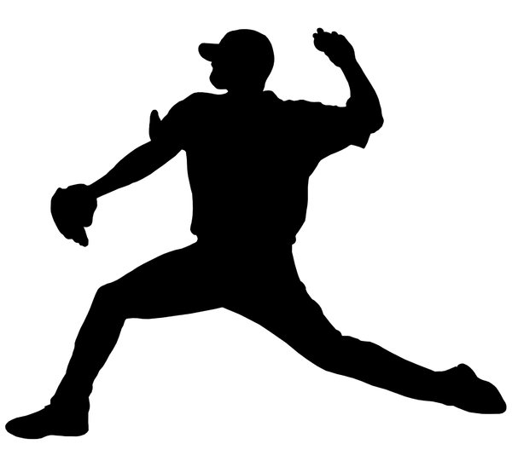
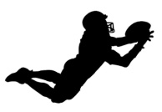
Unit Focus/Content Area: (Overhand) Throwing & Catching

Grade Level: Kindergarten, 1st grade, 2nd grade, 3rd grade, 4th grade, 5th grade

Elementary GLSP: pre-control, control, utilization, proficiency

Movement Concept(s): space awareness -> location, directions, levels, pathways, extensions -> low, middle & high
effort -> time, force, flow -> strong & light
relationships -> of body parts, with objects, with people -> near/far

Skill Theme(s) with Cues: overhand throwing- side to target, step with opposite foot, release past ear, follow through
catching- ready position, eyes on ball, reach, secure catch

Interdisciplinary Focus: energy/force & gravity in Science

National (SHAPE America) Standards:
Standard 1. The physically literate individual demonstrates competency in a variety of motor skills and movement patterns.
Standard 2. The physically literate individual applies knowledge of concepts, principles, strategies and tactics related to movement and performance.
Standard 4. The physically literate individual exhibits responsible personal and social behavior that respects self and others.

State (CPALMS) Standards:
Psychomotor-
PE.K.M.1.9 Throw a variety of objects forcefully using an overhand motion.
PE.K.M.1.7 Catch a variety of self-tossed objects.
PE.1.M.1.9 Demonstrate an overhand-throwing motion for distance using correct technique.
PE.1.M.1.7 Move in different directions to catch a variety of self-tossed objects.
PE.2.M.2.8 Demonstrate an overhand-throwing motion for distance demonstrating correct technique and accuracy.
PE.2.M.2.7 Move in different directions to catch a variety of objects softly tossed by a stationary partner.
PE.3.M.1.8 Throw balls of various sizes and weights to a stationary partner using a correct overhand motion.
PE.3.M.1.7 Move in different directions to catch objects of different sizes and weights thrown by a stationary partner.
PE.4.M.1.8 Throw balls of various sizes and weights to a stationary partner from varying distances using a correct overhand motion.
PE.4.M.1.7 Move in different directions to catch objects of different sizes and weights thrown by a stationary partner from varying distances.
PE.5.M.1.8 Throw a leading pass overhand to a moving partner using a variety of objects.
PE.5.M.1.7 Catch a variety of objects while traveling and being defended.

Cognitive-
PE.K.C.2.5 Recognize the concept of a dominant hand/foot for throwing/striking/kicking patterns.
PE.1.C.2.7 Identify dominant hand/foot for use with throwing/dribbling/striking/kicking skills.
PE.2.C.2.5 Explain how appropriate practice improves the performance of movement skills.
PE.3.C.2.5 Explain how appropriate practice improves performance of movement skills.
PE.4.C.2.6 Compare and discuss skills/sports that use similar movement patterns.
PE.5.C.2.6 Compare and contrast skills/sports that use similar movement patterns and concepts.

Affective-
PE.K.R.5.3 Identify ways to treat others with respect during physical activity.
PE.1.R.5.3 Demonstrate consideration of others while participating in physical activity.
PE.2.R.5.1 Identify ways to cooperate with others regardless of personal differences during physical activity.
PE.3.R.5.3 Identify ways to take responsibility for his/her own behavior.
PE.4.R.5.2 List ways to encourage others while refraining from insulting/negative statements.
PE.5.R.5.1 Describe a benefit of working productively with a partner to improve performance.
Unit Focus/Content Area: (Overhand) Throwing & Catching

Week # Lesson #1- overhand throwing Date(s):
Semester # #2- catching
#3- stations
#4- games

Materials/Equipment Needed: various sizes/types of bean bags, balls, noodles, & targets

Instant Activities (Warm-Ups): -The Pacer, locomotor (travelling) skills practice,
-dance or fitness apps/videos,
-tag, or review games

Instruction (Introduction/Informing):
-What are we learning today? how to overhand throw/catch

-Why are we learning this? both skills are used in a variety of sports (i.e., baseball, football), and
to develop competence & confidence needed for lifetime physical activity

-How will we know that we learned it? when we can recall and demonstrate the cues:
overhand throwing- side to target, step with opposite foot, release past ear, follow through
catching- ready position, eyes on ball, reach, secure catch

Tasks (Skill Focus): -practicing the cue(s) stressing SAFETY! (i.e., is your partner ready?)
-overhand throwing foam/gator balls for various distances
-overhand throwing foam/gator balls at mid-high-low level targets
-overhand throwing on the move
-self-toss & catch a bean bag with 2 hands, 1 hand, & at varied levels
-creative self-toss & catch (i.e., one hand, clap, spin)
-overhand throwing a foam/gator ball against the wall and catching the rebound
-overhand throwing and catching a noodle/football with a partner (starting from knee)
-overhand throwing and catching footballs on the move (Pattern Passing)
-overhand throwing and catching with defense (Keep Away)

Educational Games (Culminating Activities): -Clean Your Room, Rain Makers (with goals)
-Tower Takedown, Angry Birds/Hula Hut Throw Down
-Monster Ball/Moon Ball
-Power I Relay, Flicker Ball/Ultimate Football

Essential Questions: -What components of fitness did we work on today?
-What concept/skill did we work on today?
-In what (other) sports/activities do you use this concept/skill?
-What are the cues for this skill?
-How do these cues help you perform the skill?
-In what other skills do you use these cues?
-What other subject area did we work on today?
-What is a strategy you used or could use in a game-type situation?
-How would you rate yourself (green, yellow, or red) on your skill level?
-How could you improve your skill level?

Cool-Down: -yoga apps/videos
-or fitFlow Yoga for Kids cards

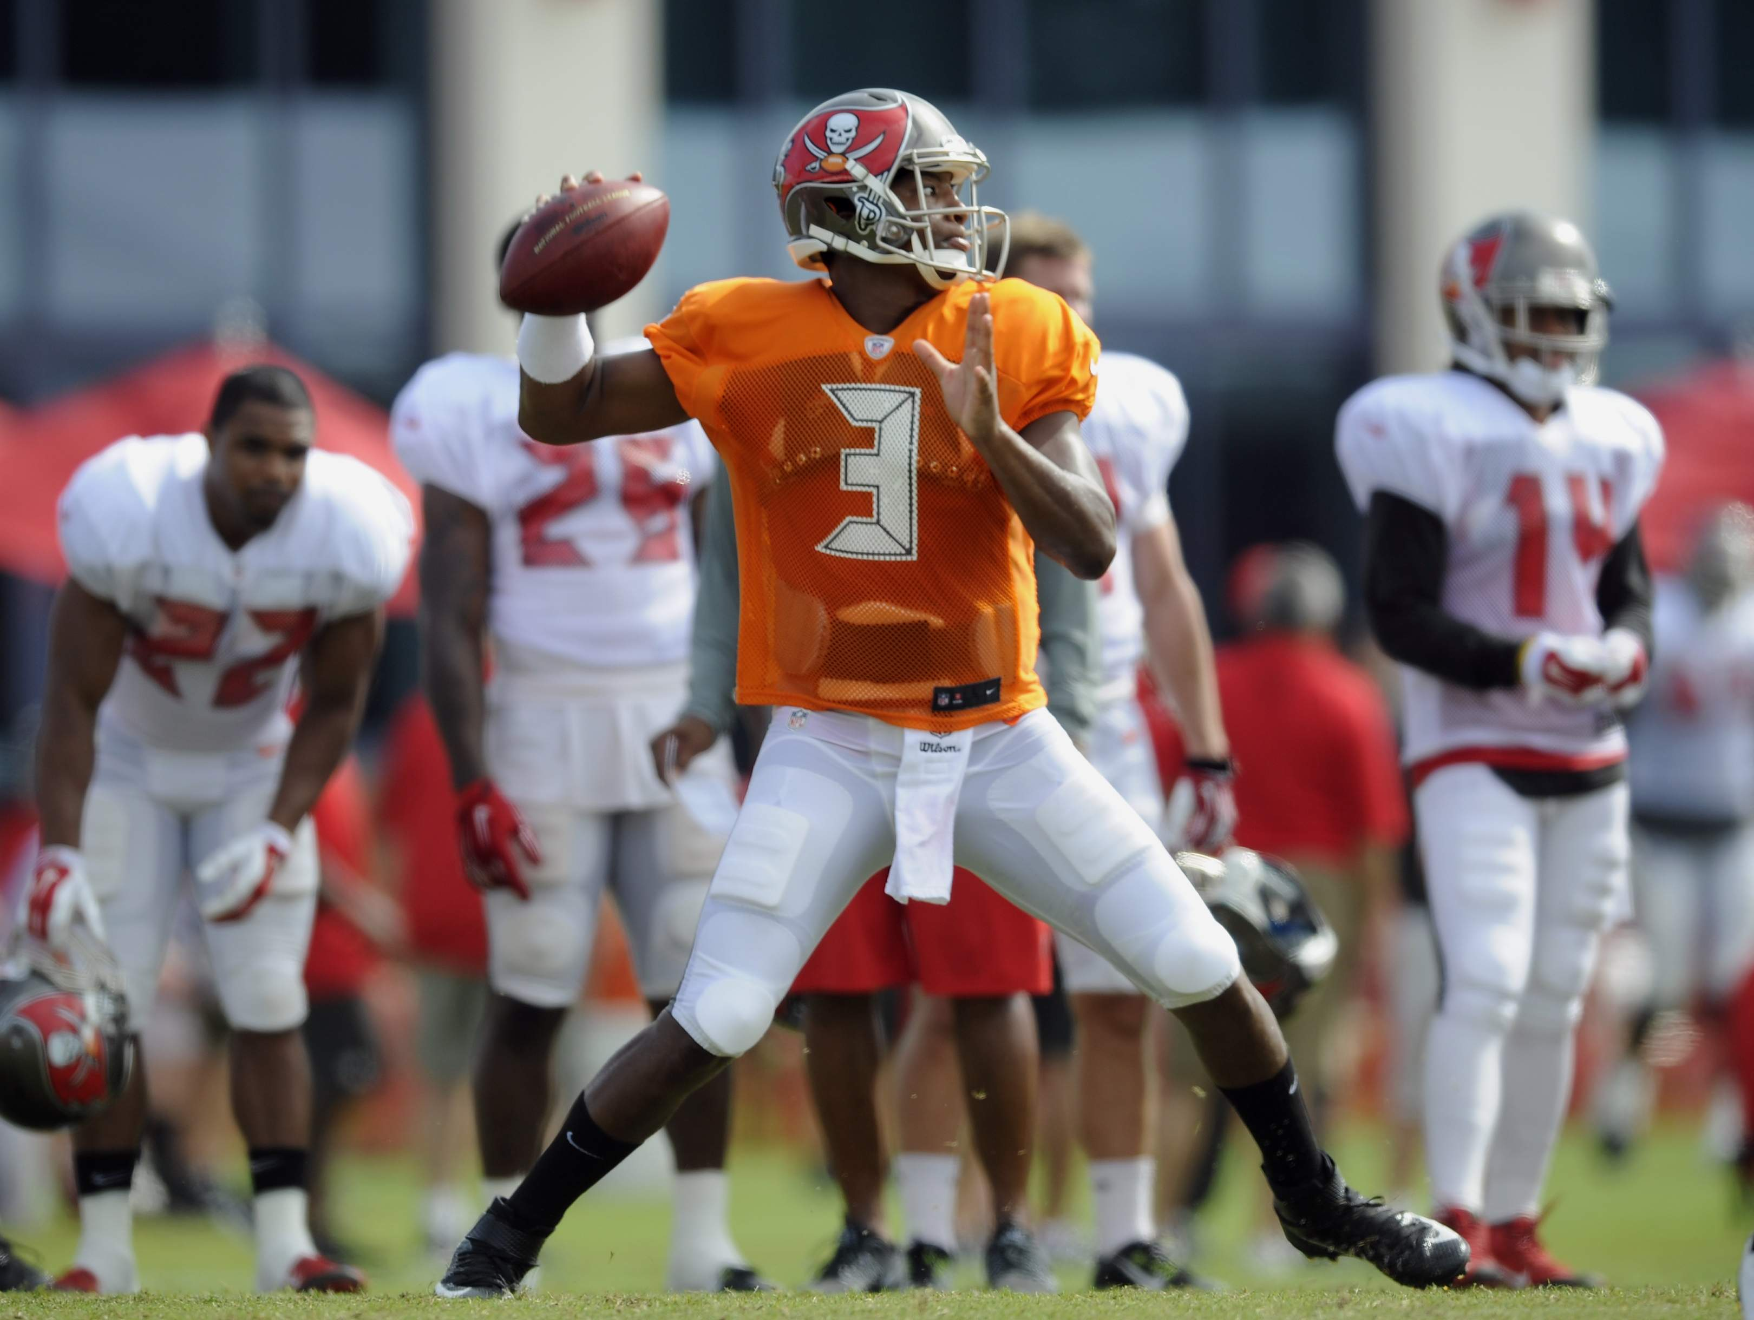

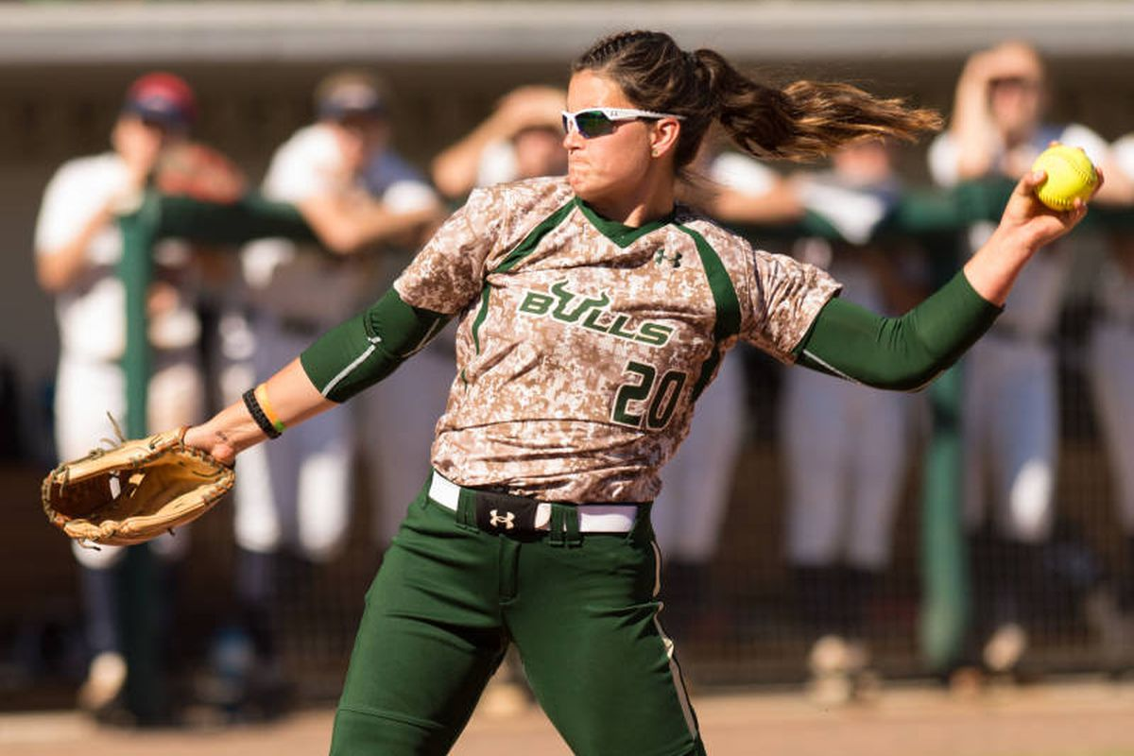

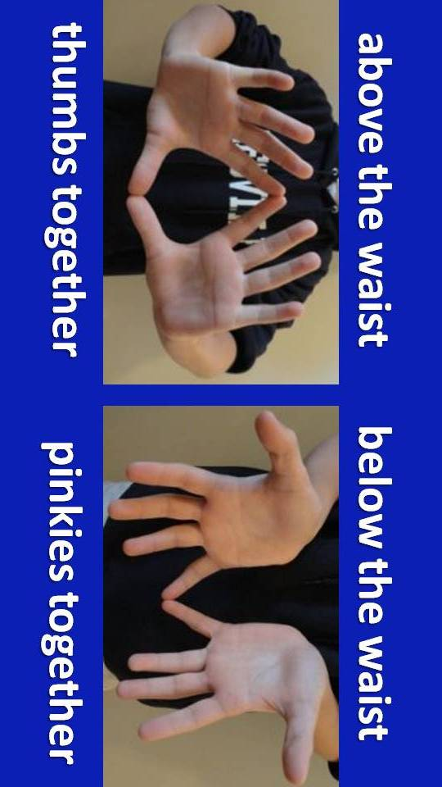

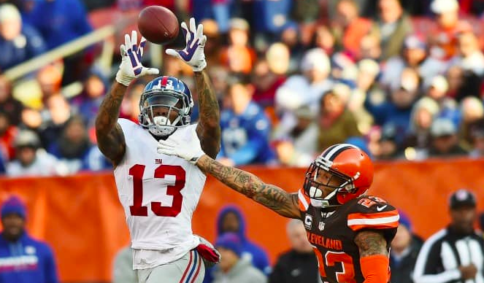

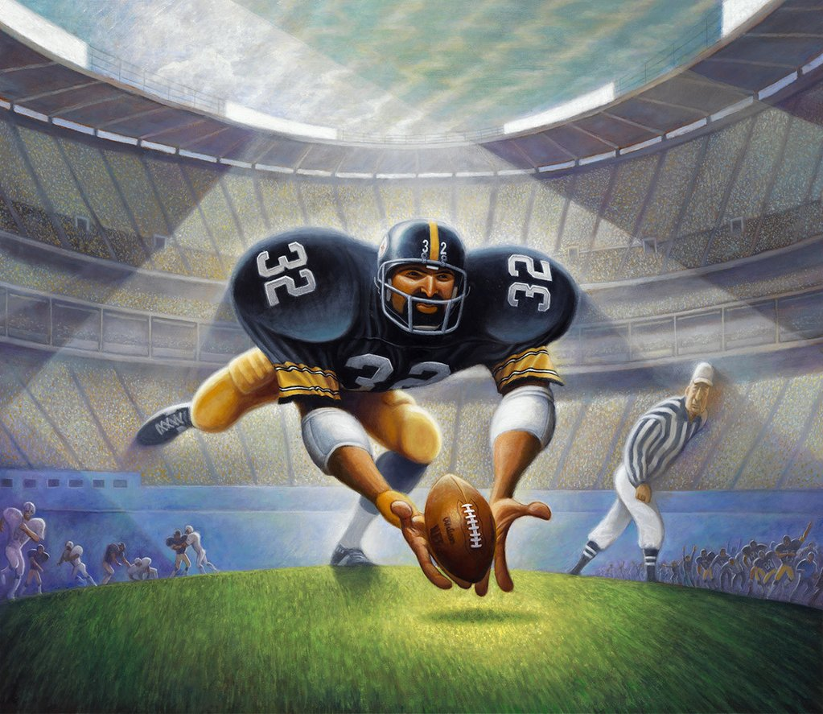

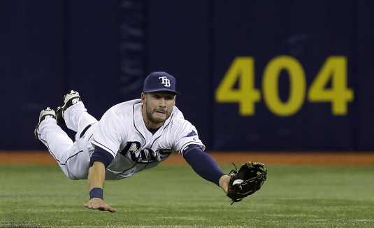

Joanne M., Landy, and Landy Maxwell J. Ready-to-Use P.E. Activities For Grades 3-4. West Nyack: Parker, 1992. 199 & 201. Print.

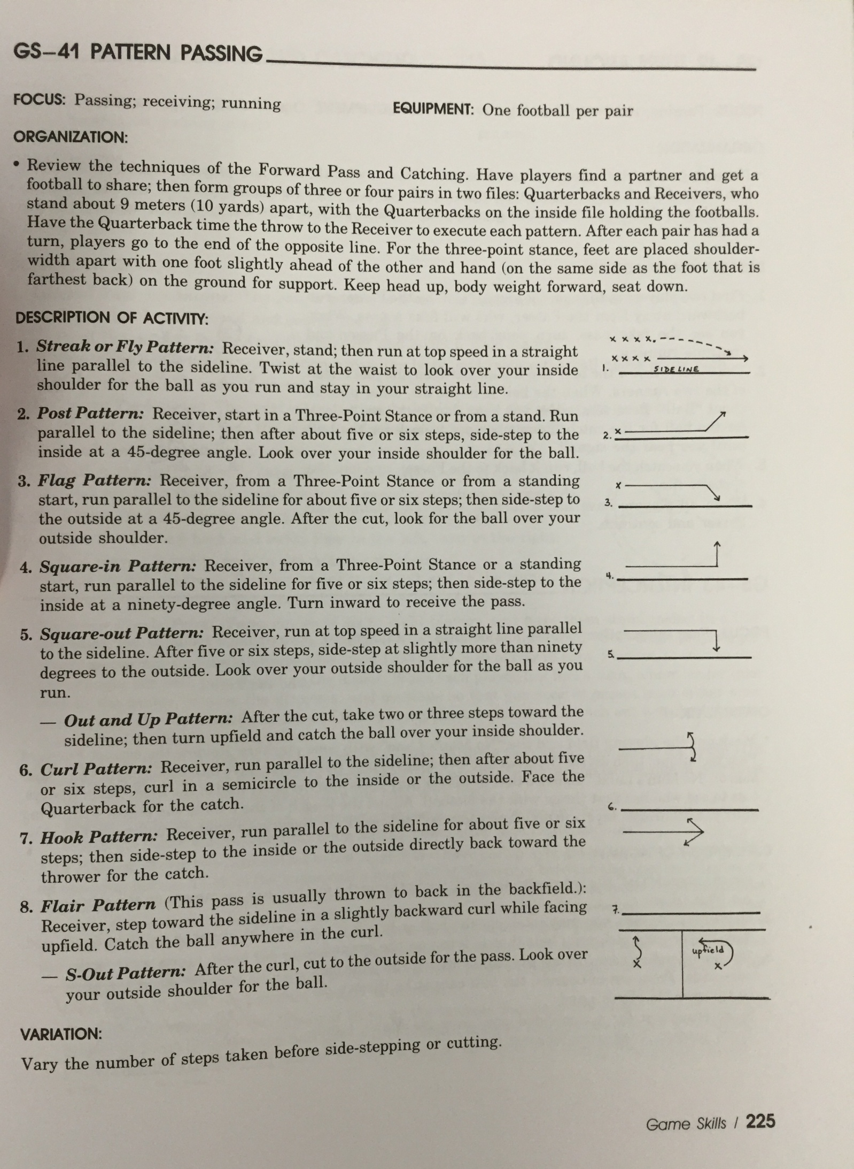
Joanne M., Landy, and Landy Maxwell J. Ready-to-Use P.E. Activities For Grades 7-9. West Nyack: Parker, 1992. 225. Print.

http://lessonplanspage.com/PECleanYourRoomGameIdea35.htm/

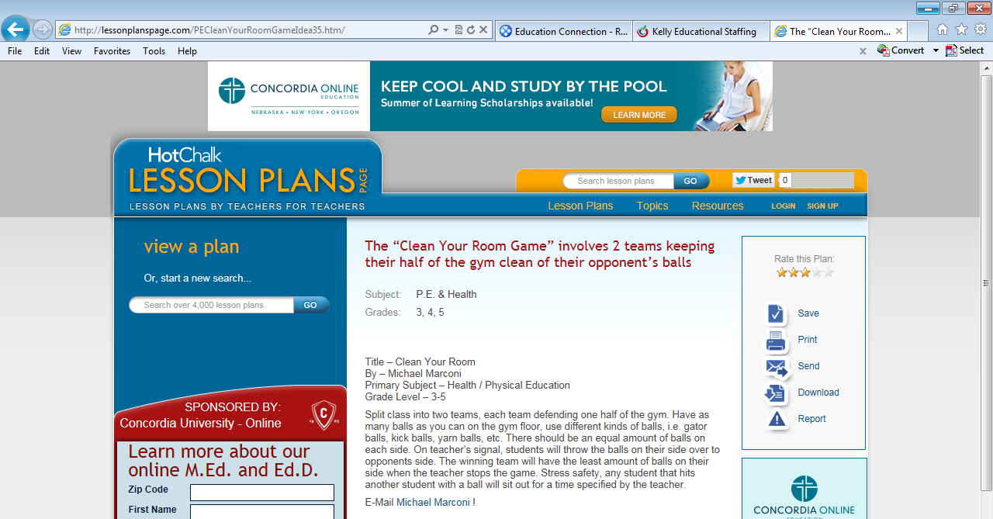

https://www.fueluptoplay60.com/~/media/files/tools-pdfs/futp-60-embedded-tool_flag-football-curriculum-elementary-school.ashx
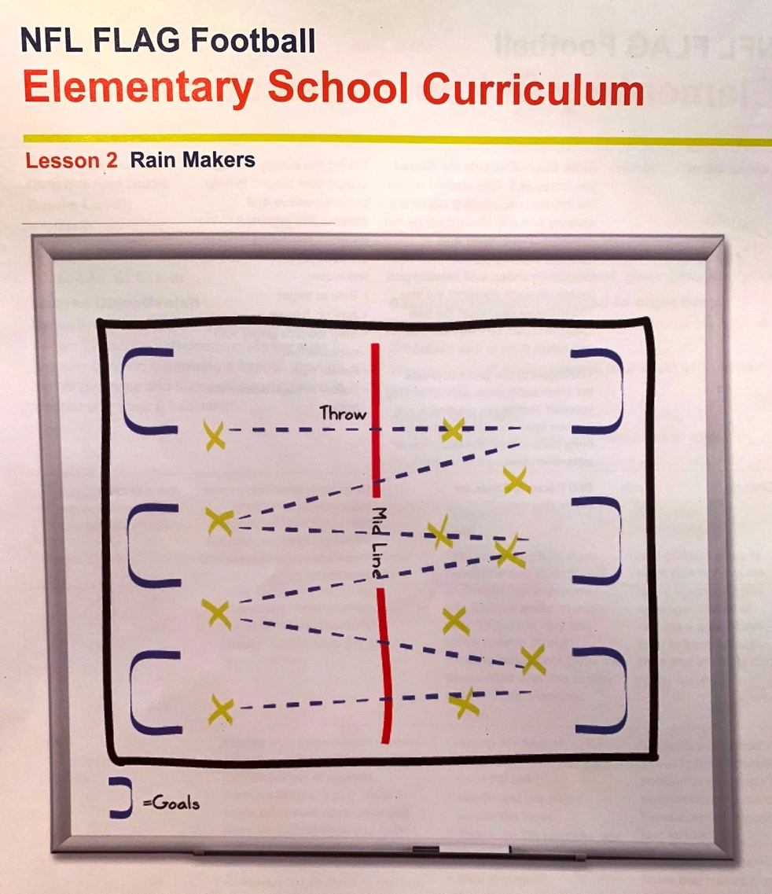

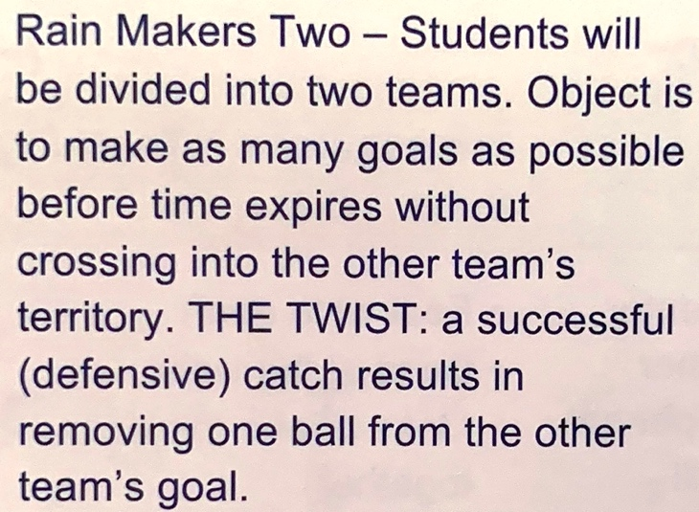

https://www.pewithmrg.org/single-post/PEThrowingGame
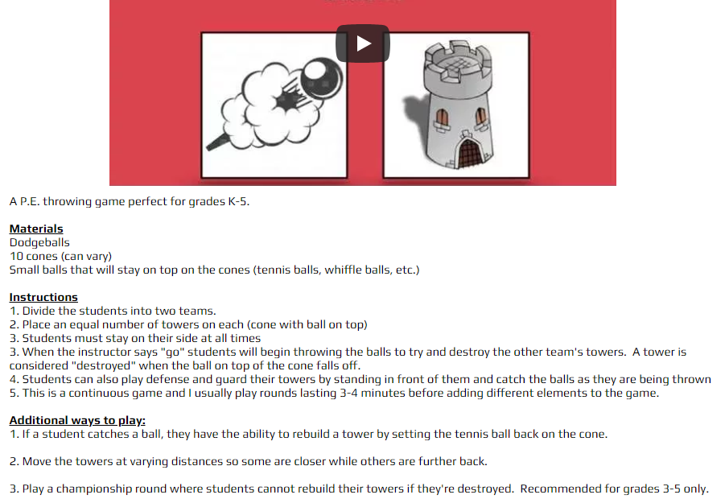

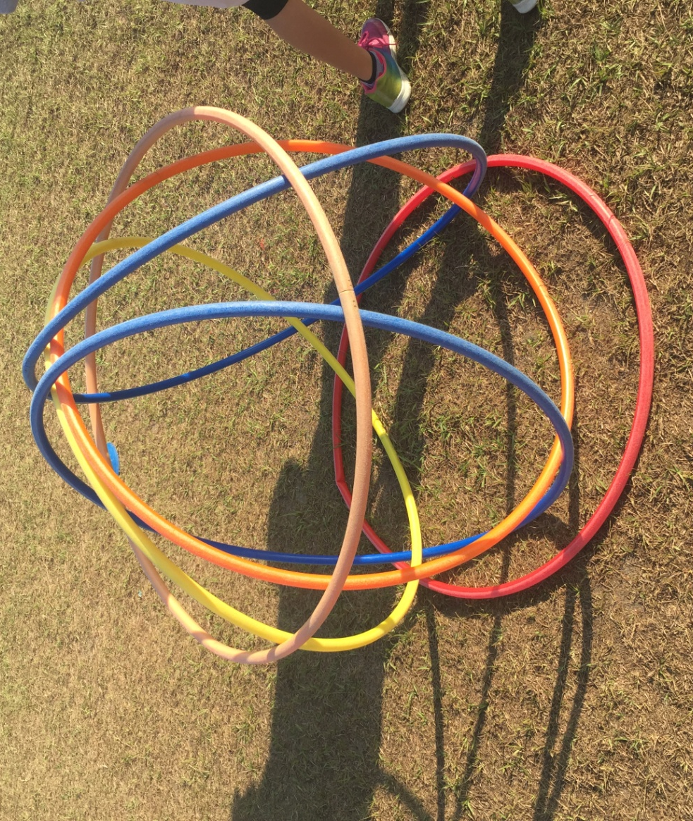
https://www.thepespecialist.com/hulahutthrowdown/

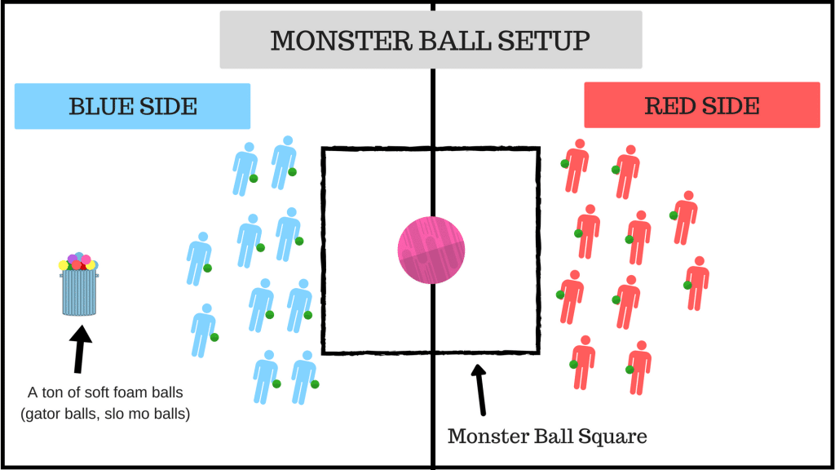
https://www.thepespecialist.com/monsterball/
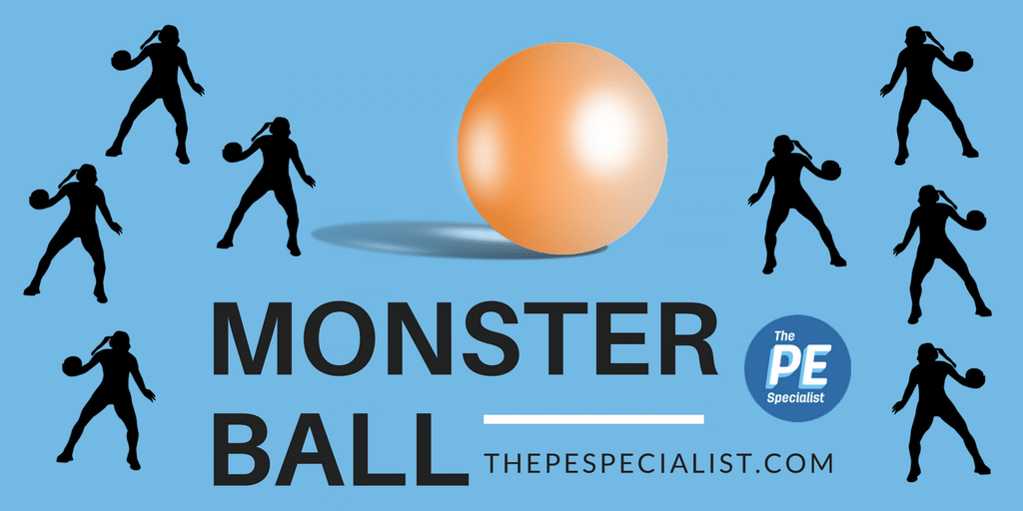

Equipment/Setup:
-One large Exercise Ball, Kin-ball or Cageball
-A bunch of gatorskin balls or any soft balls safe for throwing
-Divide students up into 2 teams and have students sit on their team’s side of the large square or circle in the middle of the gym facing toward the other team

Description:
-On the command students will attempt to throw the small ball at the Monster Ball in order to make it move. Their goal is to try and get the Monster ball to cross the line on the opposing team’s side of the square/circle/line. If the Monster Ball rolls outside of the designated area – the opposing team’s side will receive one point. Play to a specific number of points or for most points within a time limit.
If you do not have a center circle or center square in your gym or playing space, you can create an area with poly spots, cones, long jump ropes or floor tape.
Dump out all the small balls and have students pick up 2 balls and line up on their lines before the giving the signal for the game to begin.

Game Rules:
-You may go ANYWHERE to get a ball
-You must be OUTSIDE of the square (or middle area) to throw the ball
-If you throw from inside the square, sit out for that round or suffer a penalty (i.e., hop on one foot 50 times, count 60 seconds on the wall, throw left handed for the rest of the game)
-No blocking balls with your body (standing in front of the Monster Ball)
-No touching the Monster Ball – 1 point for opposing team if anybody touches the Monster Ball
-1 point for opposing team when the Monster Ball crosses the line

Strategies:
-Jamming the Monster Ball by rolling the small balls
-Hit the Monster Ball in the middle-top to help it roll easier
-Use teamwork – all throwing at the same time
-Waiting for opposite team to throw first so ball is closer and then you throw to reverse the direction and the other team will be all out of ammo
-Don’t just stand there watching after you throw – immediately go get a ball to throw again – the quicker you move, the more chance your team will have to win

Variations:
-Larger class sizes – Try playing with 4 teams (Red, Blue, Green, Yellow) If the ball leaves the middle square area in your team’s corner of the court you will receive one point… the team with the LEAST number of points wins the game after 10 minutes
-Using multiple Monster Balls – Add in more than one ball and keep track of points as they cross the lines. Once they cross the other team’s line they must stay out of the playing area and can’t re-enter the game. If you are using different sized balls, award more points for a larger ball than a smaller ball.
https://www.fueluptoplay60.com/~/media/files/tools-pdfs/futp-60-embedded-tool_flag-football-curriculum-elementary-school.ashx
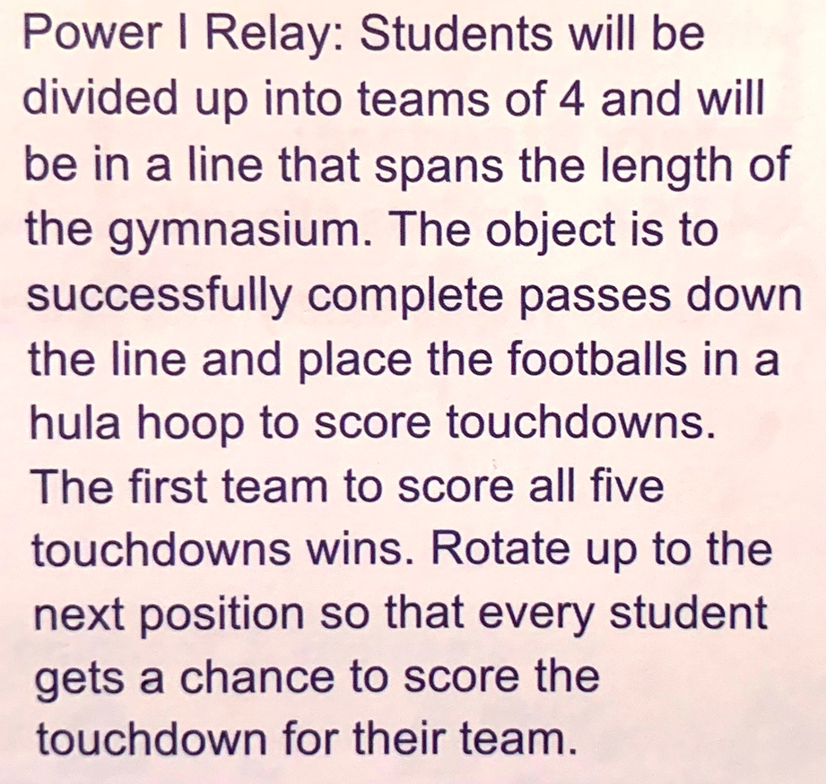

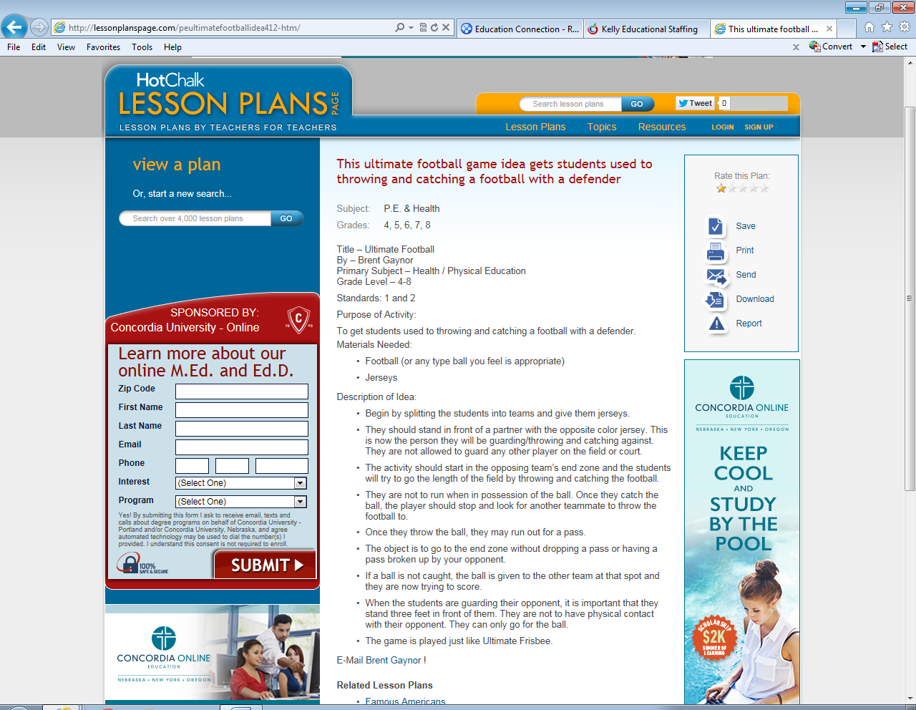
http://lessonplanspage.com/peultimatefootballidea412-htm/

